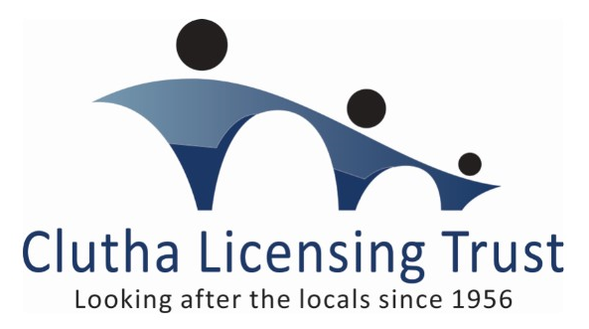
SPONSORSHIP APPLICATION FORM
Name of Event: __________________________________
Contact Person: __________________________________
Date/s of Event: ____ / ____ /____ to ____ / ____ /____
Contact Number/s: _____________________
Email Contact: _______________@________________
Postal Address: ________________________________ Postcode: ____
Nearest Trust Venue to your event: _____________________________

Sponsorship Value Requested: $ __________ Gift Vouchers or Services
(select one of the above)
Details about your event: __________________________________________________________________________________________________________________________________________________________________________________________________________________________________________________________________________________________________

In return for the Trust’s approved sponsorship, will we be offered any of the following opportunities?
- Advertising
- The sale/supply of liquor products, goods and/or services
- Naming Rights

Please detail below: ______________________________________________________________________________________________________________________________________________________________________________
Please Email this form to: mail@clt-trust.co.nz

